

PERSONAL INFORMATION Burim Beqiri

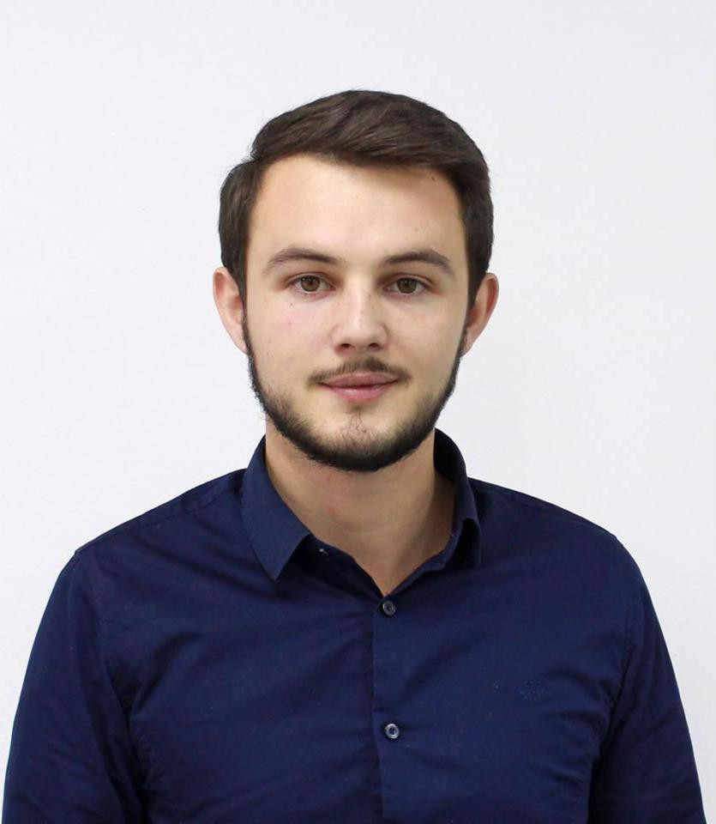
 Veternik, Prishtinë, 10000 Prishtinë (Kosovo)  +38349393201
 burim.beqiri@kolegji-heimerer.eu  Skype burim.beqiri

STUDIES APPLIED FOR Management

WORK EXPERIENCE

01/07/2013–31/08/2015 Marketing manager

Heimerer College, Prishtina (Kosovo)
Researched and analysed market trends, competitor offerings, demographics, and other information that affects marketing strategies.
Used research findings and analysis to provide direction to upcoming marketing projects, new services, and overall organization strategy.
Identified areas for improvement in college's product offerings, marketing strategy, and promotional activities.

01/09/2015–30/11/2016 Board of Directors' Assistant

Heimerer College, Prishtina (Kosovo)
Coordinated all board meetings.
Was the first point of contact of the board of directors for people from outside and inside the organization.
Arranged meetings.
Prepared presentations for the board of directors. Set discussion points.

01/12/2016–31/01/2020 Executive Assistant to the Executive Director

Heimerer College, Prishtina (Kosovo)
Prepared financial statements, reports, memos, and other highly important documents. Filed and retrieved corporate records, documents, and reports.
Researched and conducted data to prepare documents for review and presentation by boards of directors and executives.

01/02/2020–Present Chief operating officer

Heimerer Therapeutic Center, Prishtina (Kosovo)
Design and implement business strategies, plans and procedures. Set comprehensive goals for performance and growth.
Establish policies that promote company culture and vision.
Oversee daily operations of the company and the work of executives. Lead employees to encourage maximum performance and dedication.

Evaluate performance by analyzing and interpreting data and metrics. Write and submit reports to the CEO in all matters of importance.

01/03/2018–Present Project manager - Volunteer

NGO Me Dhe Per Kosoven, Prishtina (Kosovo)
Ensure that all projects are delivered on-time, within scope and within budget.
Assist in the definition of project scope and objectives, involving all relevant stakeholders and ensuring technical feasibility.
Ensure resource availability and allocation.
Develop a detailed project plan to monitor and track progress.
Manage changes to the project scope, project schedule and project costs using appropriate verification techniques.

01/03/2015–31/03/2016 Coordinator - Volunteer
NGO "World in Pictures", Zenica (Bosnia and Herzegovina) Followed office workflow procedures to ensure maximum efficiency. Maintained files and records with effective filing systems.
Supported other teams with various administrative tasks. Monitored office expenditures and handle all office contracts.

01/06/2017–Present Coordinator - Volunteer

Institute of Southeast Europe for Health and Social Policy, Prishtina (Kosovo)
Monitor office supplies inventory.
Assist in vendor relationship management.
Perform bookkeeping activities and update the accounting system. Maintain files and records with effective filing systems.

EDUCATION AND TRAINING

01/10/2008–05/07/2012 Certificate in General high school

Hamëz Jashari, Skenderaj (Kosovo)

01/10/2012–17/04/2019 Certificate in Political Science Program With Specialization In Public Administration

BPrAL - PPoHE Universum College, Prishtinë (Kosovo)

EQF level 6

18/04/2023–22/04/2024 Certificate in International MBA

Rome Business School

06/10/2017–07/10/2017 Certificate Of Presentation: Policy in Relation with Health of, https://econpapers.repec.org/article/eurejisjr/219.htm Citizen

13th INTERNATIONAL CONFERENCE ON SOCIAL SCIENCES, Vienna (Austria)

PERSONAL SKILLS

Mother tongue(s) Albanian

Foreign language(s)
UNDERSTANDING |  | SPEAKING |  | WRITING
Listening | Reading | Spoken interaction | Spoken production

English C1 C1 B2 B2 B2
Levels: A1 and A2: Basic user - B1 and B2: Independent user - C1 and C2: Proficient user Common European Framework of Reference for Languages - Self-assessment grid

Communication skills Excellent communication skills and presentation of required materials and reports Confident in public speaking
Excellent body language Active listening and questioning

Organisational / managerial skills Excellent teamwork and individual skills
Excellent organization skills Excellent research skills
Excellent ability to extract, analyze and visualize data

Job-related skills Decision Making.
Communication. Creativity.
Critical Thinking.
Interpersonal Communication. Adaptability.

Digital skills SELF-ASSESSMENT

Information processing | Communication | Content creation | Safety | Problem- solving
Proficient user | Proficient user | Independent user | Independent user | Proficient user
Digital skills - Self-assessment gr

